**Lab Program 1:**

Develop a Java program that prints all real solutions to the quadratic equation ax2 +bx+c = 0.  Read in a, b, c and use the quadratic formula. If the discriminate b2-4ac is negative, display a message stating that there are no real solutions.

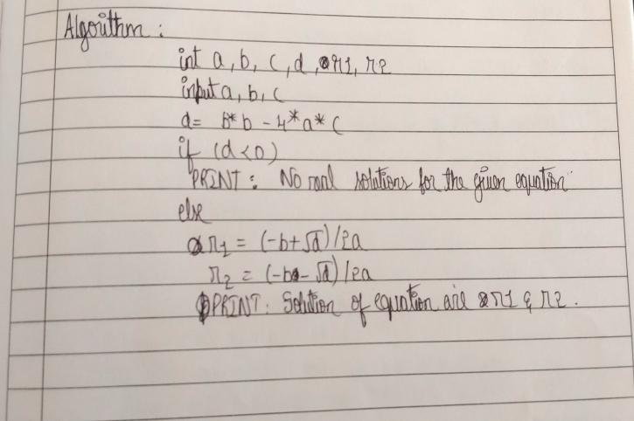

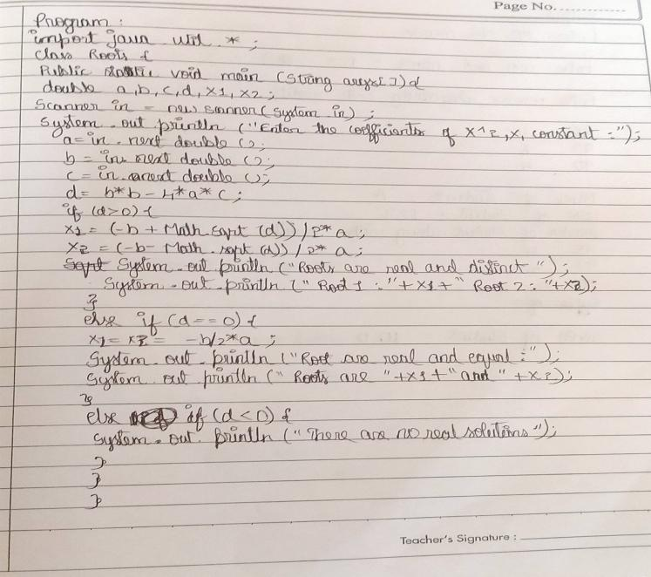

**Output-**

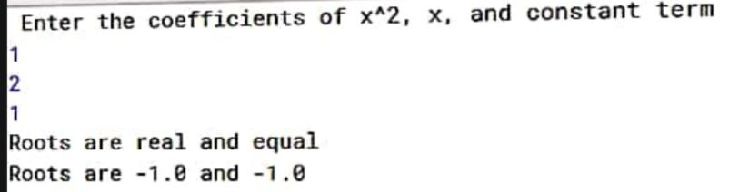

**Lab Program 2:**

Develop a Java program to create a class **Student** with members **usn, name**, **an array credits** and **an array marks**. Include methods to accept and display details and a method to calculate SGPA of a student.

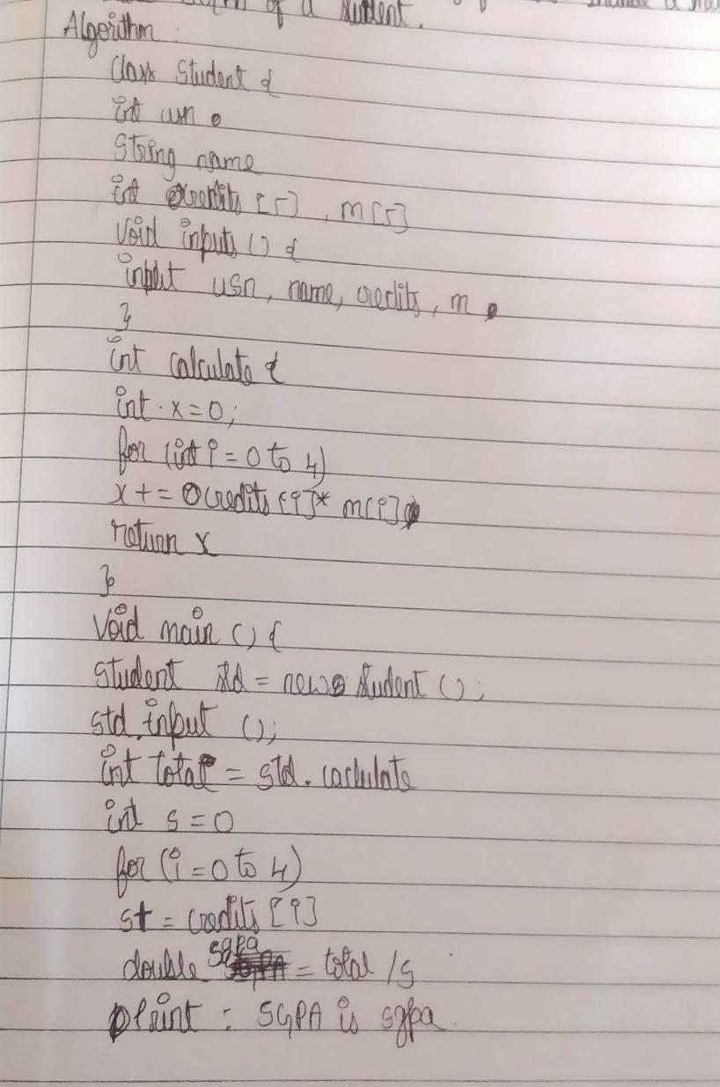

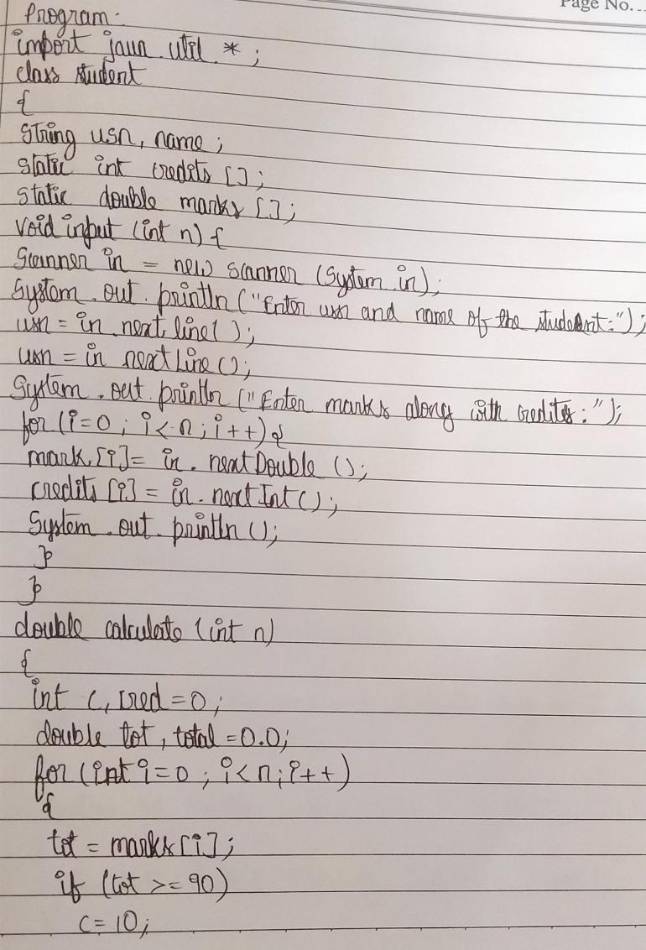

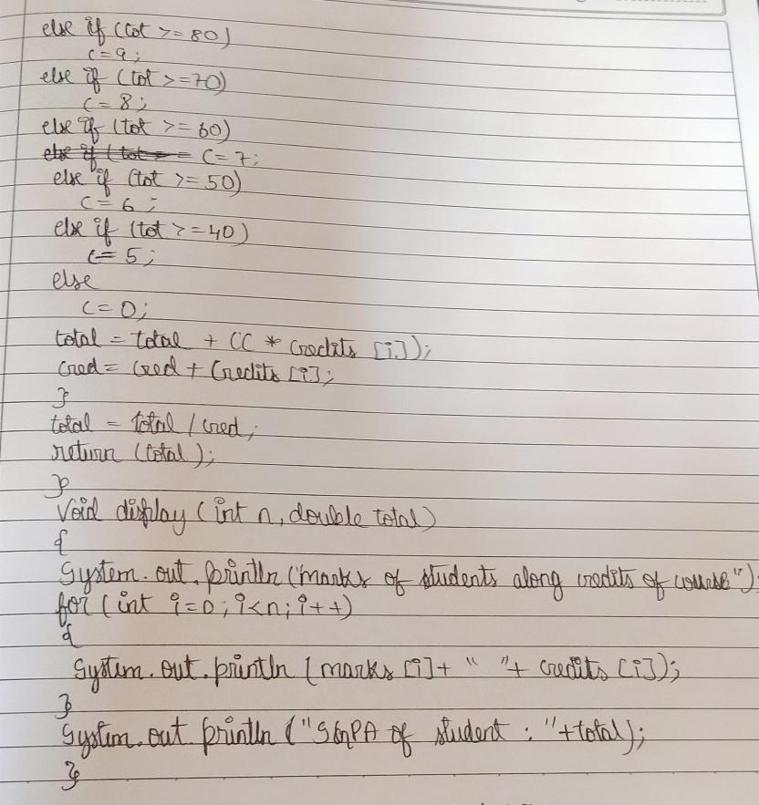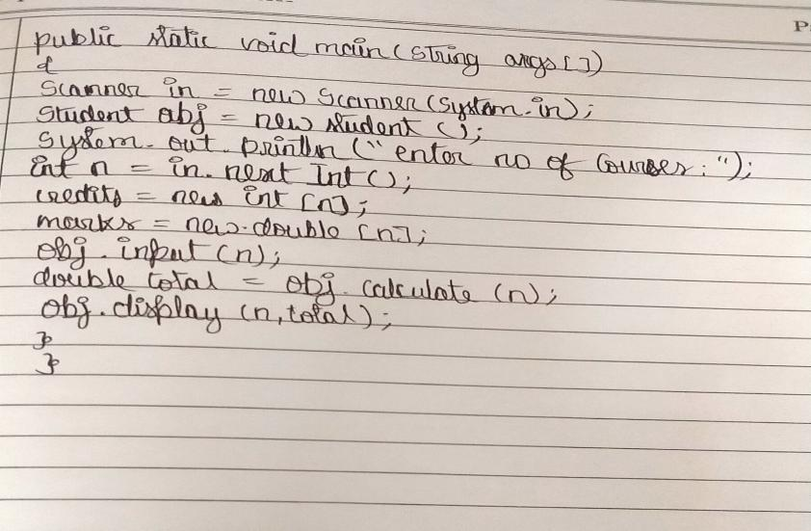**Output-**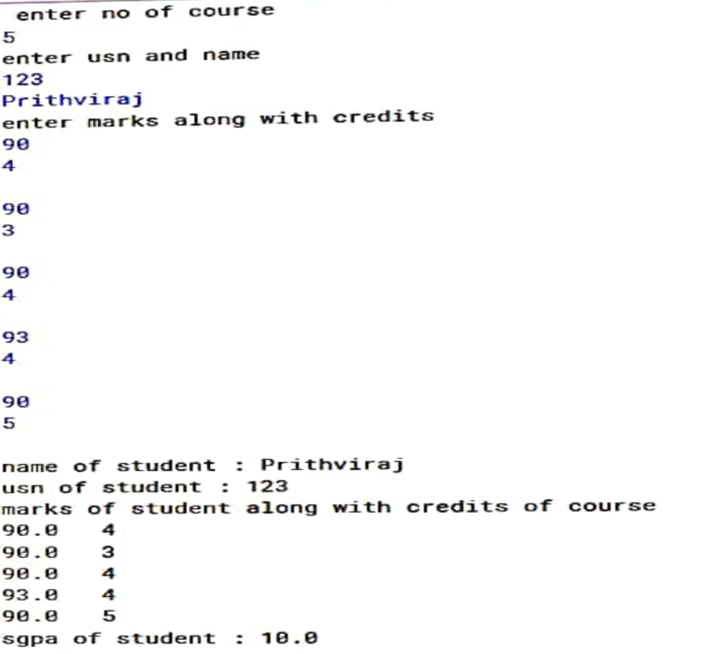

**Lab Program - 3**

Create a class Book which contains four members: name, author, price, num_pages. Include a constructor to set the values for the members. Include methods to set and get the details of the objects. Include a toString( ) method that could display the complete details of the book. Develop a Java program to create n book objects.

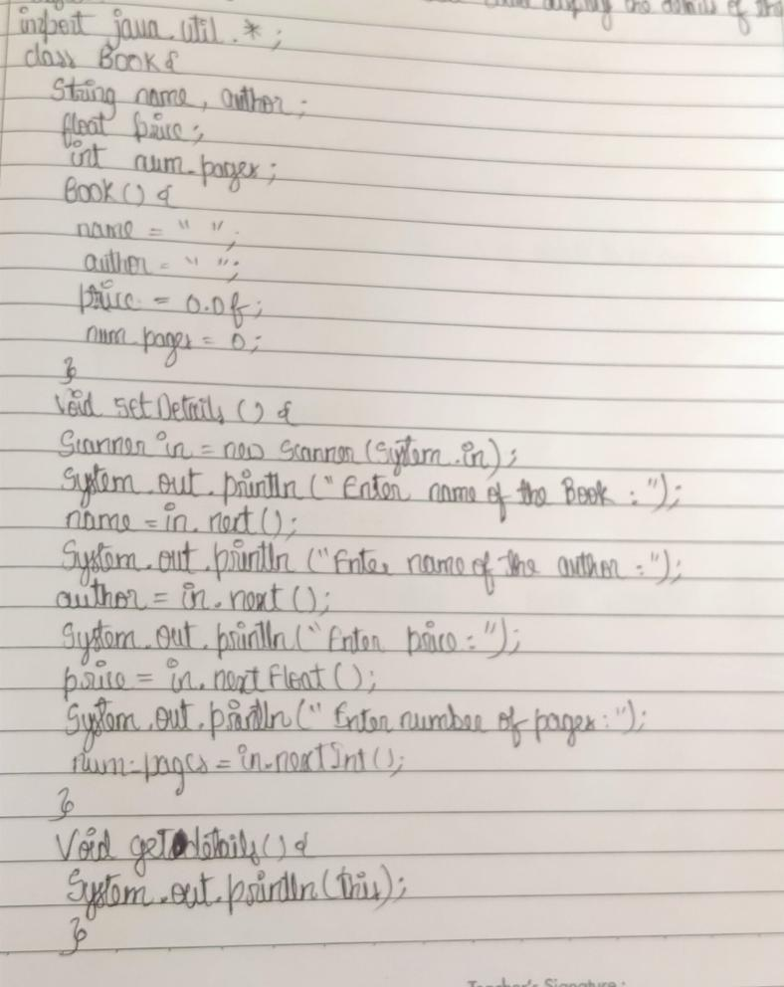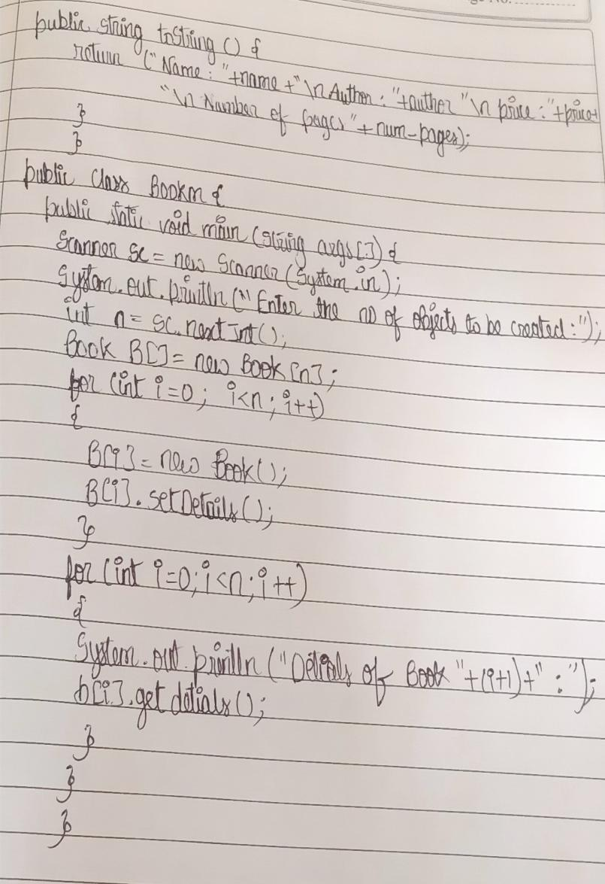

**Output-**

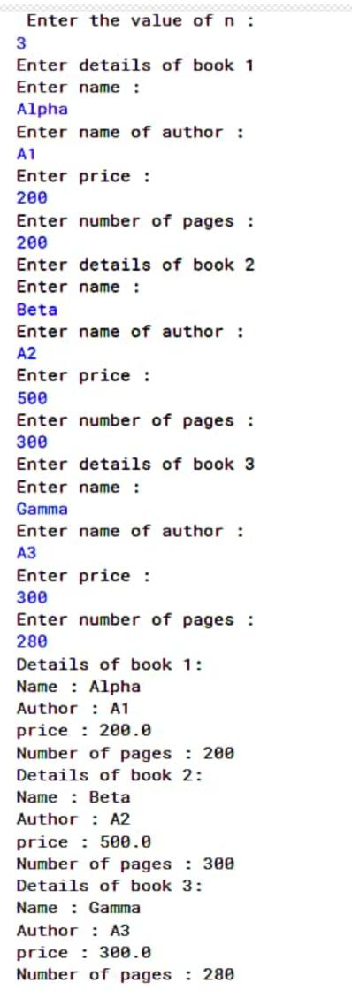

**Lab Program 4:**

Develop a Java program to create an abstract class named Shape that contains two integers and an empty method named printArea(). Provide three classes named Rectangle, Triangle and Circle such that each one of the classes extends the class Shape. Each one of the classes contain only the method printArea( ) that prints the area of the given s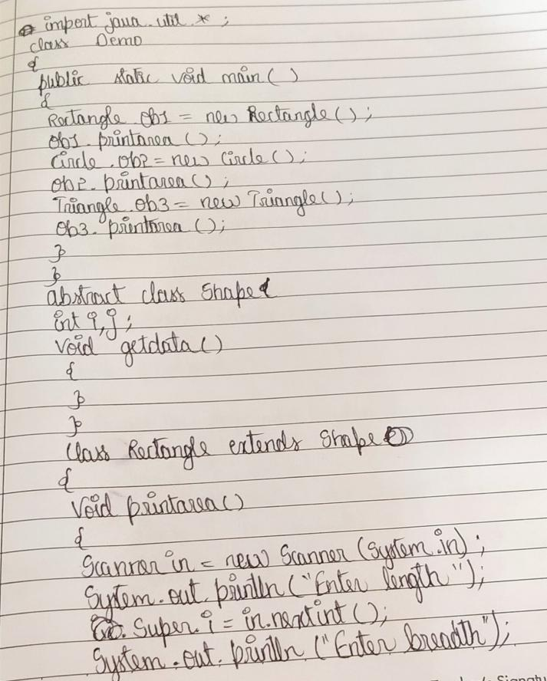hape.

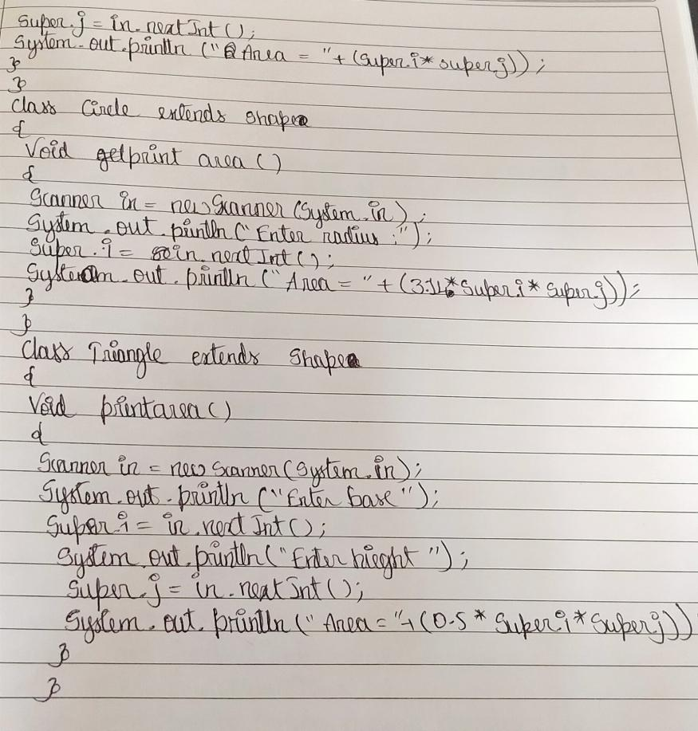

**Output:**

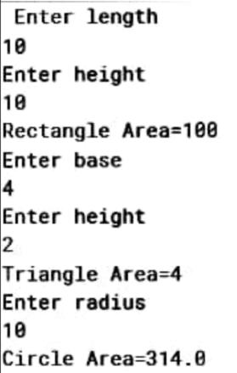

**Lab Program 5:**

Develop a Java program to create a class Bank that maintains two kinds of account for its customers, one called savings account and the other current account. The savings account provides compound interest and withdrawal facilities but no cheque book facility. The current account provides cheque book facility but no interest. Current account holders should also maintain a minimum balance and if the balance falls below this level, a service charge is imposed. Create a class Account that stores customer name, account number and type of account. From this derive the classes Curr-acct and Sav-acct to make them more specific to their requirements. Include the necessary methods in order to achieve the following tasks: • Accept deposit from customer and update the balance. • Display the balance. • Compute and deposit interest • Permit withdrawal and update the balance • Check for the minimum balance, impose penalty if necessary and update the balance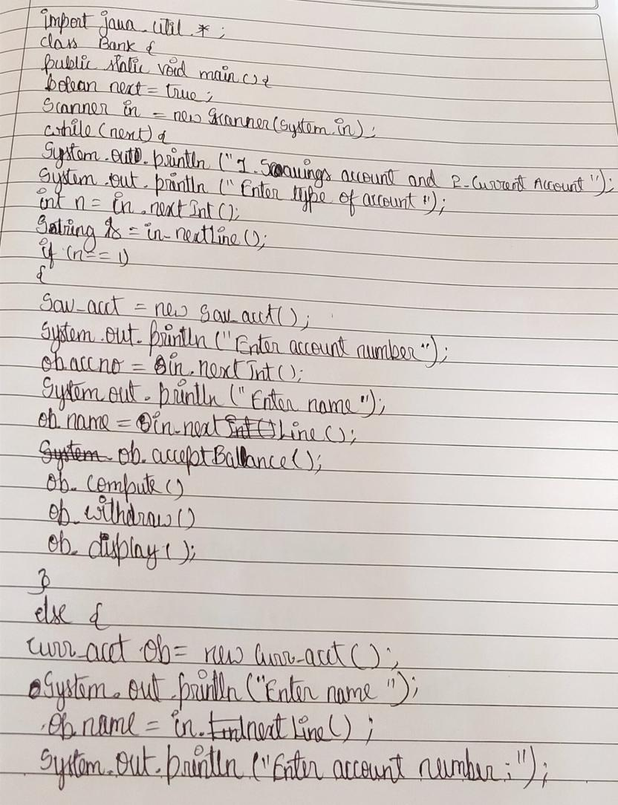

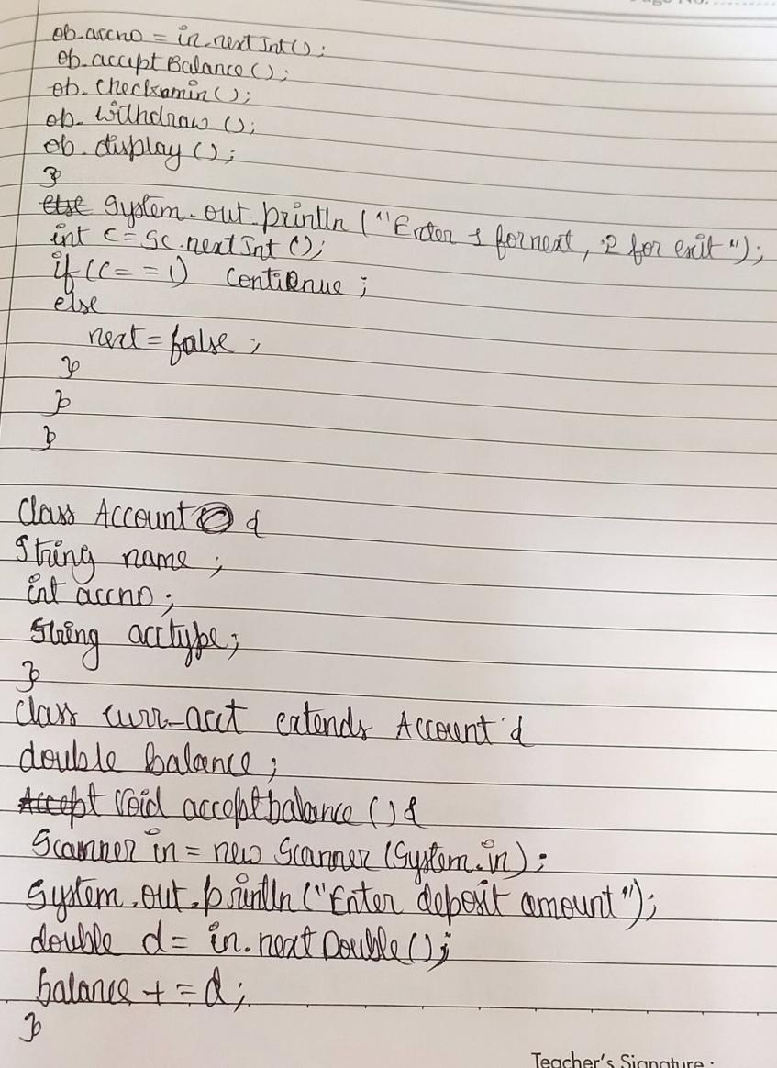

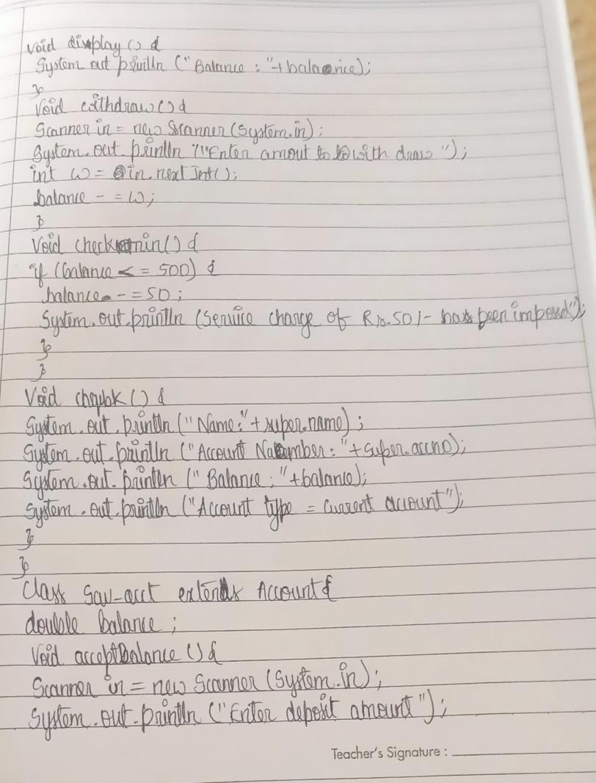

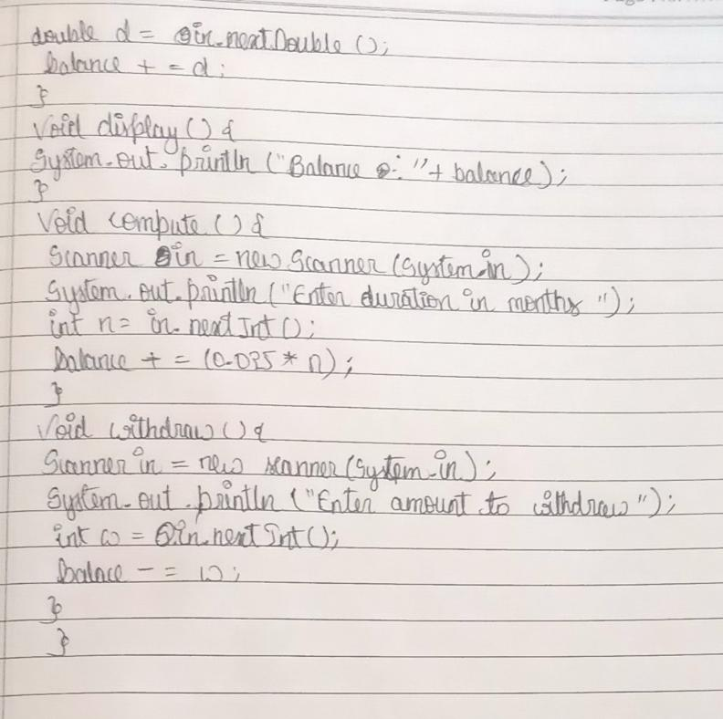

**Output:**

